G

ON SALE NOW: 2008 GATOR FOOTBALL PREVIEW DVD

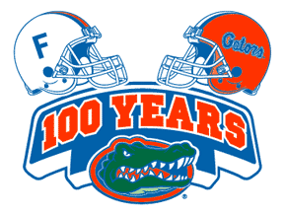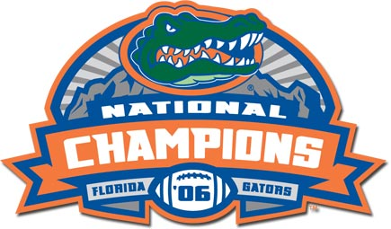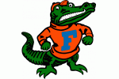

F L O R I D A

T

O

R

S

- With Guest Hosts: Tim Tebow & Urban Meyer
- Music Included: (Univ. of Florida Fight Songs)
***** Go Gators! - Orange and Blue – and Many More! *****

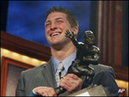

Associated Press Top 15
1 LSU
2 Georgia
3 Southern California
4 Missouri
5 Ohio State
6 West Virginia
7 Kansas
8 Oklahoma
9 Virginia Tech
10 Boston College
11 Texas
12 Tennessee
13 Florida
14 Brigham Young
15 Auburn

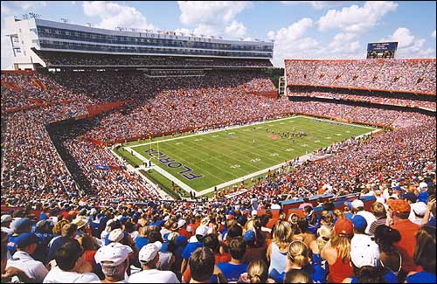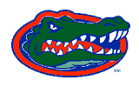

2008 – The YEAR of the GATORS…
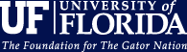
$19.95
2008 National Champions ?

2008 Special Edition DVD – ( A Look at the season Ahead. )
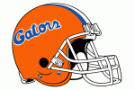

2008 Special Edition DVD – ( A Look at the season Ahead. )

